**Modeling COVID 19 spread in India**

**Modification of the Traditional SEIR Model**

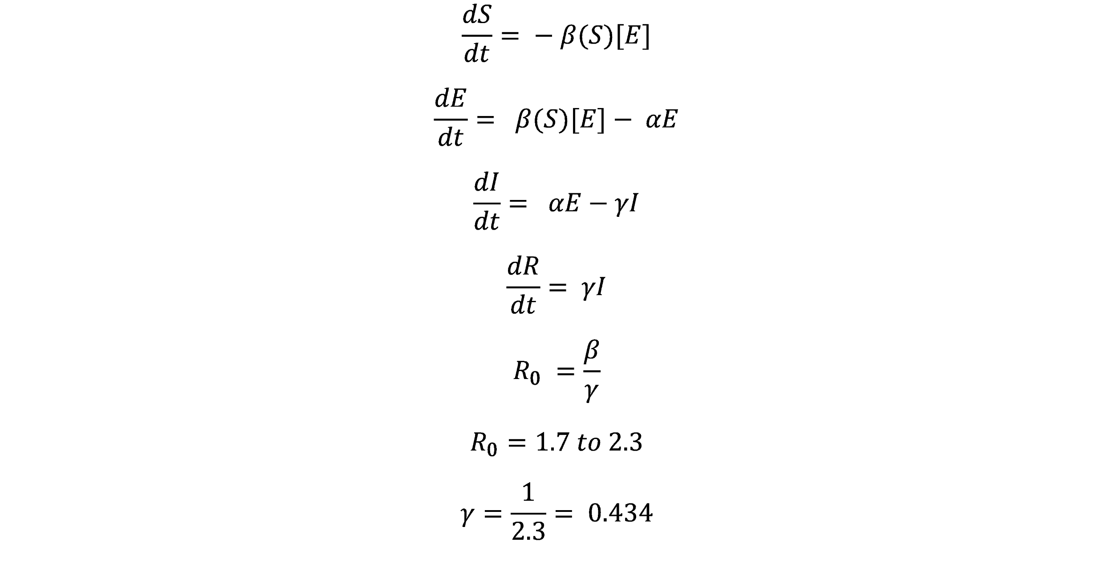

Here, () -> adjusted for lockdown by taking fraction of susceptible might get exposed

[] - > adjusted for quarantine by taking fraction of exposed might infect susceptible